Dataset review:

<https://www.kaggle.com/datasets/shivamb/vehicle-claim-fraud-detection>

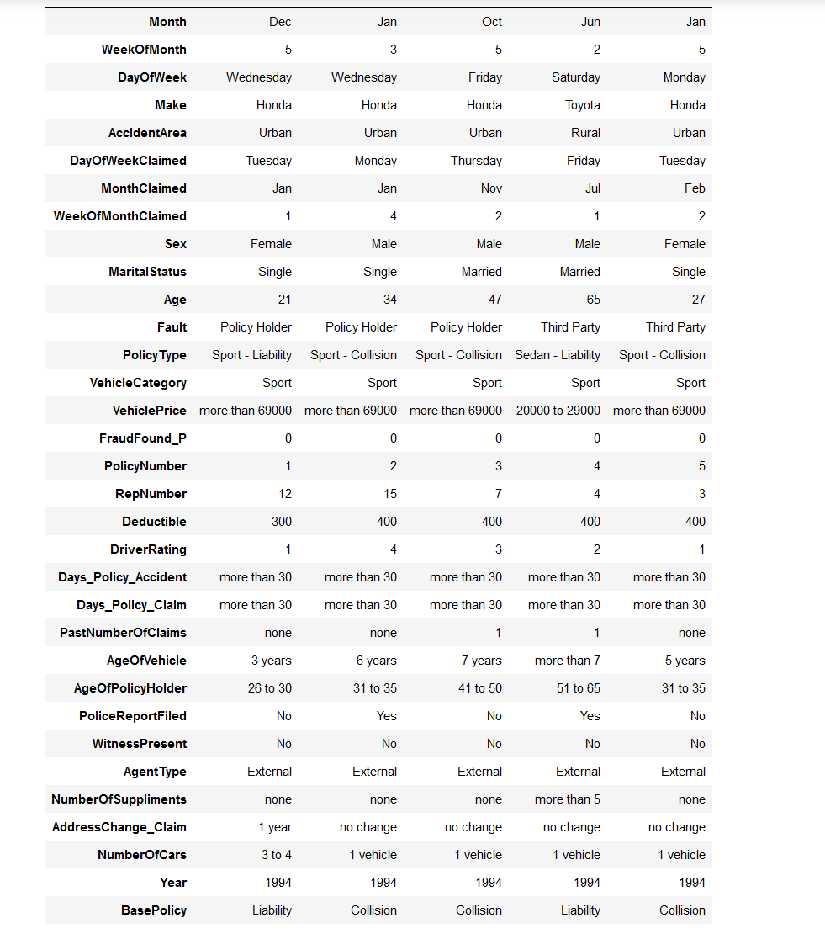

Dataset has labels and has category ‘FraudFound_P’ to indicate fraud. Only weakness of this dataset is that the target label was unbalanced. To deal with this, we under sampled the target column that was the majority.

The model used for this model is a Random Forest Classifier due to its high performance during the experimentation phase.

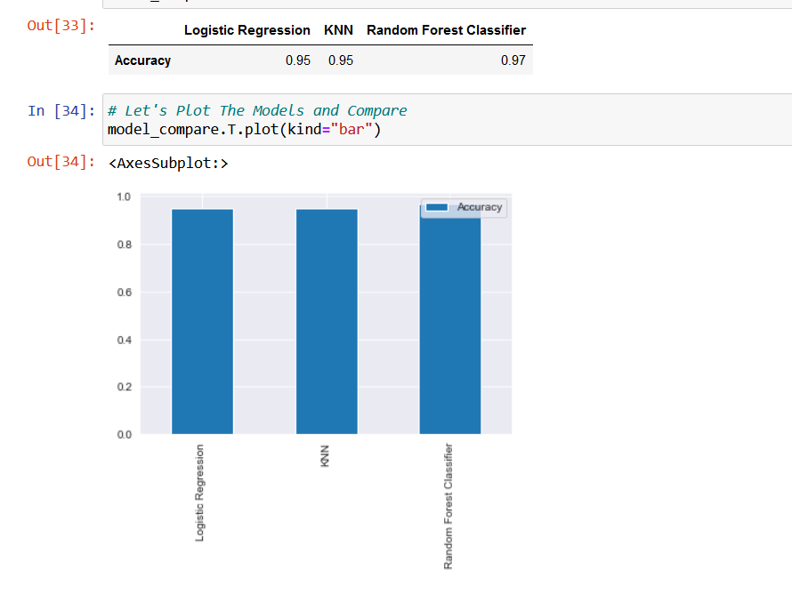

Explanation – Feature importance:

